**FPT ACADEMY INTERNATIONAL**



## FPT – APTECH COMPUTER EDUCATION

**RYANA CALENDARS**

|  |  |  |  |
| --- | --- | --- | --- |
| **Center Name** | | FPT – Aptech – HCM2  Address: 590 Cach Mang Thang Tam, District 3, Ho Chi Minh City | |
| **Instructor** |  | Ms. Le Mong Thuy |  |
| **Class** |  | T1.2208.A0 |  |
| **Group** |  | 6 |  |
| **Group members** | | **Name** | **Student ID** |
|  |  | Duong Thi Tuyet Mai | Student1405218 |
|  |  | Pham Thi My Thuy | Student1408034 |
|  |  | Ly Hong Phong | Student1408017 |
| **Duration** | Start date | 14th Nov 2022 |  |
| End date | 14th Dec 2022 |  |

**This is to certify that**

Duong Thi Tuyet Mai

Pham Thi My Thuy

Ly Hong Phong

**has successfully designed & developed**

eProject: Ryana Calendars website

**Submitted by:**

Ly Hong Phong

**Date of issue:** 14th Nov 2022

**Authorized Signature:**

**TABLE OF CONTENTS**

****FPT – APTECH COMPUTER EDUCATION 1****

****TABLE OF CONTENTS**** ****2****

****ACKNOWLEGMENT**** ****3****

****SYNOSIS**** ****3****

****PROBLEM DEFINITION**** ****3****

****CUSTOMER'S REQUIREMENTS SPECIFICATIONS (CRS) 4****

****Business/Project Objective**** ****4****

****Hardware/ Software Requirements**** ****5****

****SCOPE OF THE WORK (IN BRIEF) 6****

****Architecture and design of the system 7****

****Diagram of the website 8****

****TASK SHEET REVIEW 1 9****

****SITE MAP 10****

****MOCK OF THE WEBSITE 1********1****

***1. Homepage 1******1***

***2. Product 1******2***

***3. Blog 1******3***

***4. About Us 1******4***

***5. Contact US 1******5***

***6. Service 1******6***

***7. Sign In/ Sign Up 1******7***

****TASK SHEET REVIEW 2 18****

WEBSITE DESCRIPTION ****1********9****

RESPONSIVE****28****

[****JAVASCRIPT DESCRIPTION****](#Javascript) ****30****

****TASK SHEET REVIEW 3**** ****47****

# ACKNOWLEGMENT

On behalf of team members. I would like to thank everyone who supported my team to successfully complete this eProject report. Especially, our teacher, she has supported us a lot since we started studying at FPT Aptect. With this eProject, she guided us very meticulously, enthusiastically and strictly. With her guidance, we were able to successfully complete this project. Besides, I also want to thank all the team members, each of whom worked hard to complete the eProject in earnest during the month of working together. Finally, our group would like to say thank you to my classmates and family for sharing and creating for the group the best environment to focus on the project, motivating the members to achieve their goals.

# SYNOSIS

# The goal of the eProject is that we need to create a website that meets all the requirements of the client, Harvel Electric. Harvel Electric is an energy company specializing in the supply of various electrical products. They always satisfy customers with professional staff with many years of experience. The main goal of this website is to reach customers who need the best quality electrical products for their home or company. In addition, the products have discounts and promotions for customers, especially the company also supports the direct installation of their products. Customer satisfaction is always the top goal of Harvel Electric.

# PROBLEM DEFINITION

The Web site is to be created based on the following requirements.

1) The Home Page should be created making use of Sections with a suitable logo.

2) The site should display a menu which will contain the options for brief

introduction about the various products available, location of the shop and

any other information if required.

3) The information should be categorized according to different type of products

like if a User wants to see only ‘Journal’ then he click on a Link/button/menu

etc and he will see different type of Journal. Similarly for ‘Calendars’, ‘Diaries’

and other products.

4) When a user selects any product type, a list of products for that product type

will be displayed.

5) A brief summary of features of individual products should be displayed on the

Web Page along with the product but detailed Features should be stored in

Individual Word documents which can be downloaded or viewed by the User

who wishes to see the same.

6) Price List should be available for download.

7) There should be a “Contact Us” page which will have the Address of the

Company which should be displayed using GeoLocation API (eg. GoogleMaps)

and the email address which when clicked will invoke the local mail client

from where they can send an email.

# CUSTOMER'S REQUIREMENTS SPECIFICATIONS (CRS)

**Client: Ryana Calendars**

### Business/Project Objective:

The company advertises by distributing the pamphlets, advertising on calendars and so on. Due to rapid development in internet field, the company decides to launch a website where people will get all the information about the various products available with them easily.

You are supposed to create a website for them with the below mentioned requirement specifications.

The website is to be developed for the Windows Platform using HTML5, JavaScript and Geolocation. The site should work well in all leading browsers including Chrome, IE, Firefox etc.

**Input to the system:**

- Searching products based on Calendar, diary and other products.

- Feedback about the quality of products

- Contact us.

- Store location.

**Output from the system:**

- Display results for each type of product according to the search content.

- Display product information by price, type

- Display the special information of the product.

- Display products of the same type.

- The location of the shop under Contact-Us page.

**Process**:

* + - * Validate data input from users.

**Expected delivery date:** 14-Dec-2022.

**List of deliverables:**

- Document Word, PDF.

- User Guide.

- Source code.

### Hardware/ Software Requirements:

* **For developer**

**Hardware**

* + Intel Pentium 4 processor or higher
  + 01 Gigabytes of RAM or higher

**Software**

* + Windows 7 OS or higher
  + Adobe Dreamweaver
  + Web browsers such as IE, Chrome or Firefox are supporting HTML5, CSS3 and Javascript.
* **For web users**

**Hardware**

* + Intel Pentium 4 processor or higher
  + 512 Megabytes of RAM or higher

**Software**

* + Windows XP OS or higher
  + Web browsers such as IE, Chrome or Firefox are supporting HTML5, CSS3 and Javascript.

# SCOPE OF THE WORK

After a long and detailed discussion, our group has decided to create a website contain the following webpages:

1. ***Homepage***: There is a search bar to search for products, display promotional information, best-selling products.
2. **Introduce**: show options to recommend different products and store locations.
3. ***Product***: Displays all available products based on the Category (Calendars, Diary and Journal). In the above categories, products can be filtered by price.
4. ***About Us***: Display the information of the company, clients’ review and about us.
5. ***Contact Us***: Display the address of the company, Map and allow customers to request any information they want to Harvel Electric.

# ARCHITECTURE AND DESIGN OF THE SYSTEM

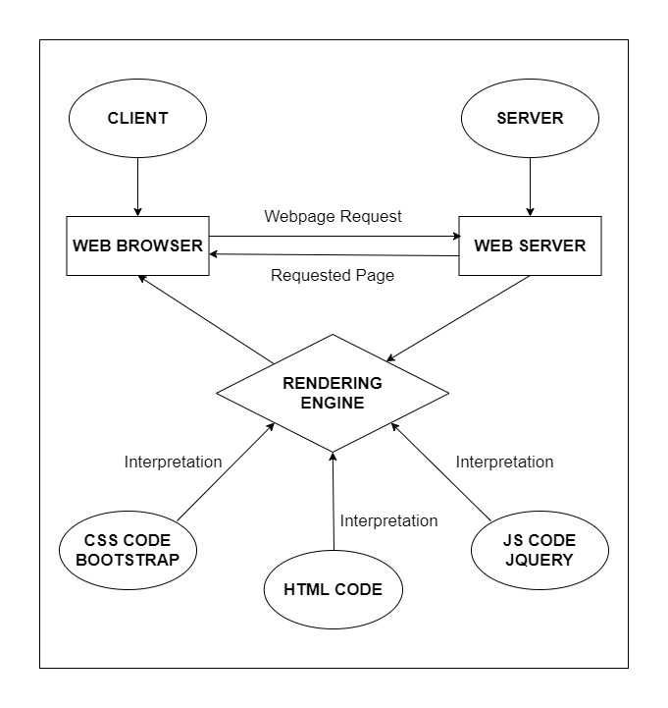

# DIAGRAM OF THE WEBSITE



# TASK SHEET REVIEW 1

|  |  |  |  |  |  |  |  |
| --- | --- | --- | --- | --- | --- | --- | --- |
| **Project Ref. No.:**  **eP/Advertisement Portal Management**  **System/01** | | **Project Title:** | **Activity Plan Prepared By:** | **Date of Preparation of Activity Plan:** | | | |
| **Sr.**  **No.** | **Task** | **Actual**  **Start**  **Date** | **Actual Days** | **Team**  **Mate Names** | **Status** |
| 1 | Problem Statement | RYANA CALENDARS | Phong | 14-Nov-22 | 1 | Mai | Completed |
| 2 | Analysis of Ryana Calendars requirements about the website | 14-Nov-22 | 1 | Phong | Completed |
| 3 | The scope of the work (in brief) | 14-Nov-22 | 1 | Thuy | Completed |

|  |  |
| --- | --- |
| **Date:** | |
| Signature of Instructor:  **Ms. Le Mong Thuy** | Signature of Team Leader:  **Ly Hong Phong** |

# SITE MAP

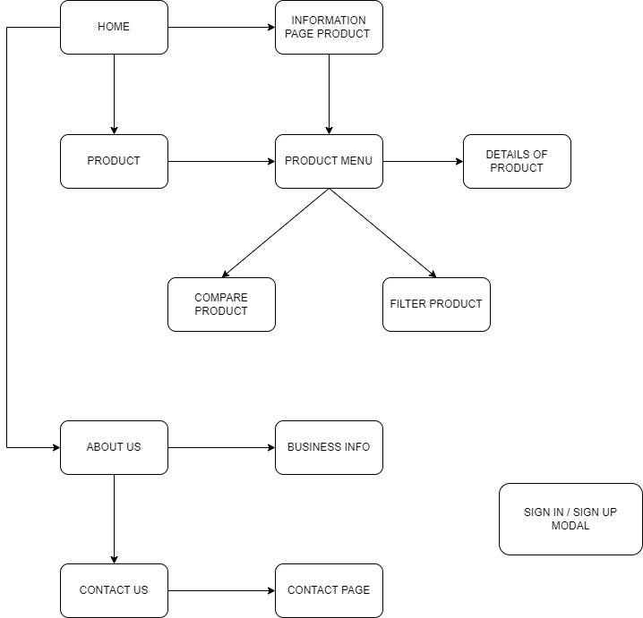

# MOCK OF THE WEB SITE

1. **Homepage**

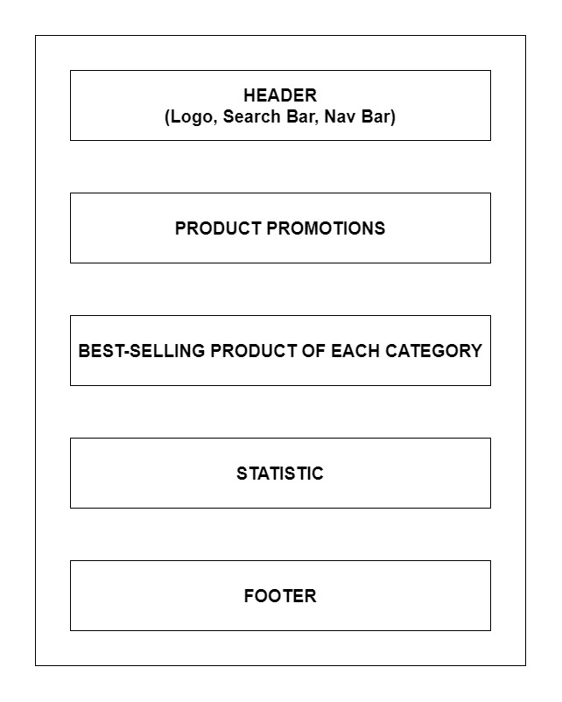

1. **Product**

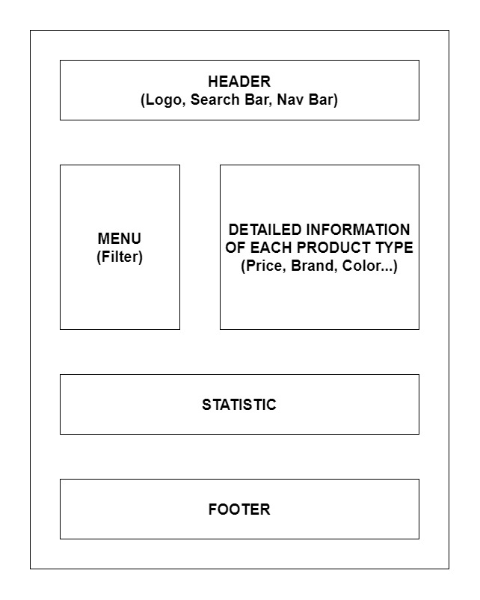

1. **About Us**

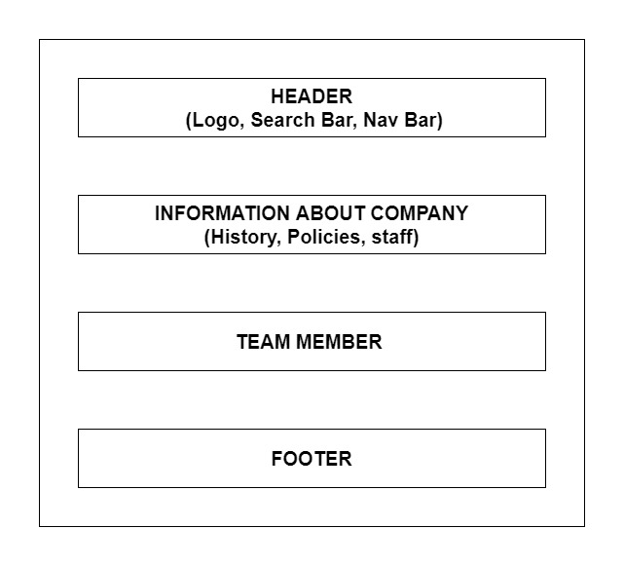

1. **Contact Us**

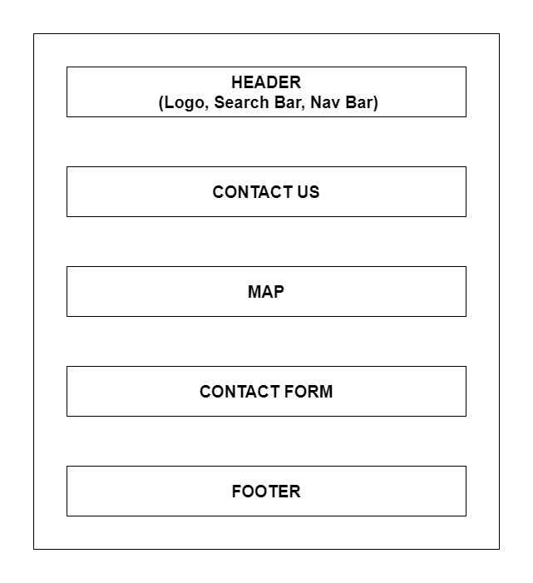

# TASK SHEET REVIEW 2

|  |  |  |  |  |  |  |  |
| --- | --- | --- | --- | --- | --- | --- | --- |
| **Project Ref. No.:**  **eP/Advertisement Portal Management**  **System/01** | | **Project Title:** | **Activity Plan Prepared By:** | **Date of Preparation of Activity Plan:** | | | |
| **Sr.**  **No.** | **Task** | **Actual**  **Start**  **Date** | **Actual Days** | **Team**  **Mate Names** | **Status** |
| 1 | Site Map | RYANA CALENDARS | Phong | 14-Nov-22 | 1 | Phong | Completed |
| 2 | Mock of the website | 14-Nov-22 | 2 | Mai | Completed |
| 3 | Task s heet | 14-Nov-22 | 2 | thuy | Completed |

|  |  |
| --- | --- |
| **Date:** | |
| Signature of Instructor:  **Ms. Le Mong Thuy** | Signature of Team Leader:  **Ly Hong Phong** |

# WEBSITE DESCRIPTION

1. **Homepage**
2. Description

Home page displays following information:

- Slide show programs, services and product promotions

- Feature product.

- Latest news (Blog).

- Popular Brand.

- Some information about the website.

1. Screen shot

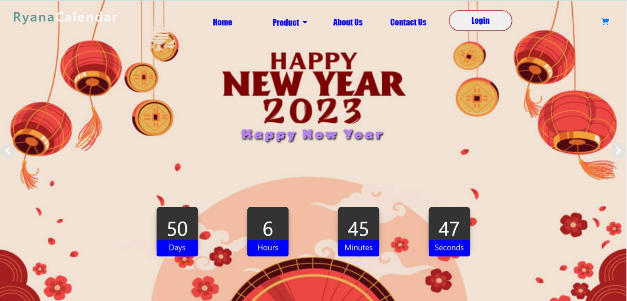

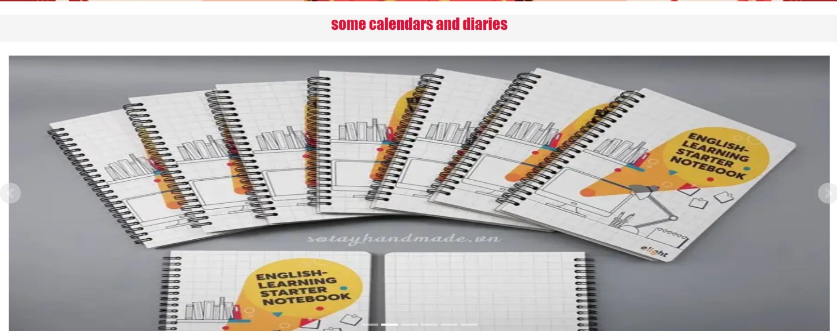

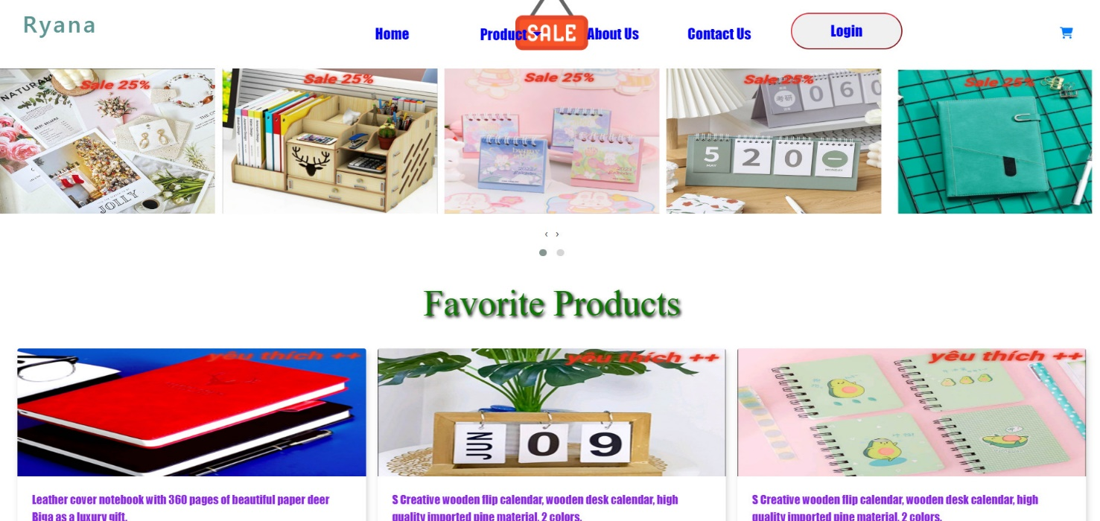

1. **Product**
2. **About Us**
3. Description

- This page displays information about the history of Rhythm House, our service that we provide and our team member.

- Display happy customer.

1. Screen shot

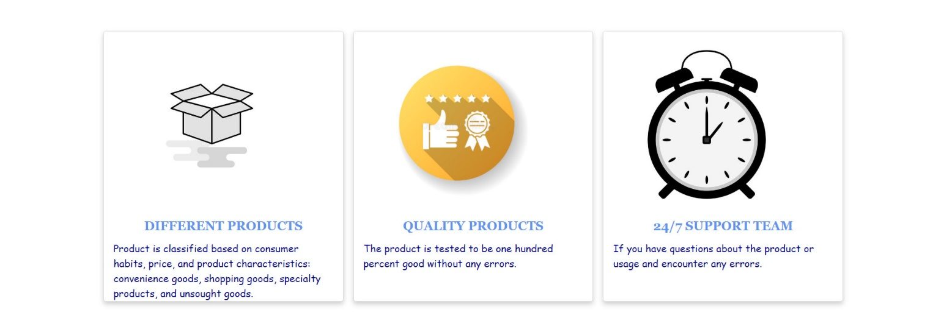

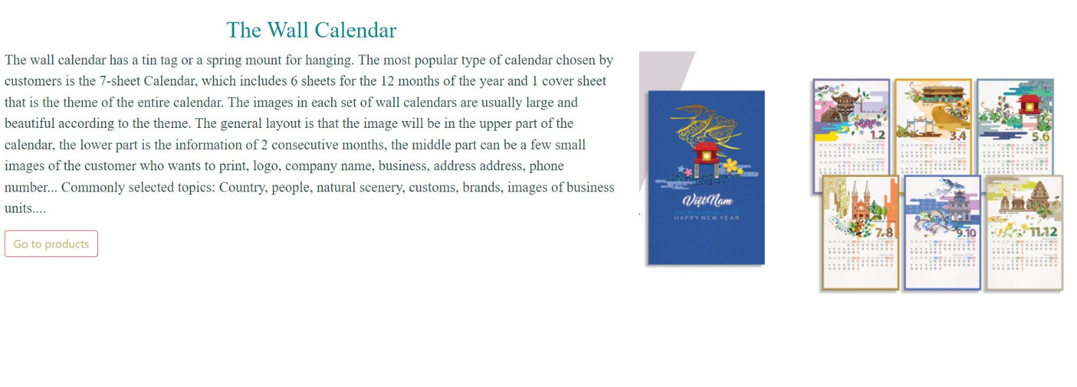

1. **Contact Us**
2. Description

This page displays contact information: location, telephone number, email and a quick contact form for customer

1. Screen shot

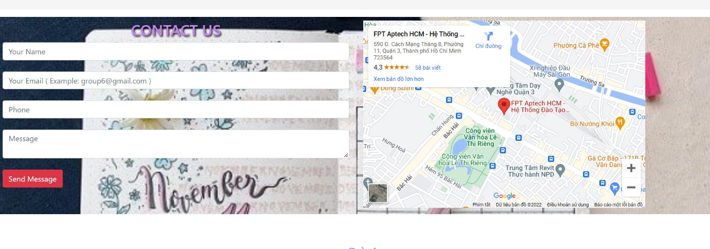

1. **Login/ Register**
2. Description

- This page displays information: Warranty terms, information, review about product.

1. Screen shot

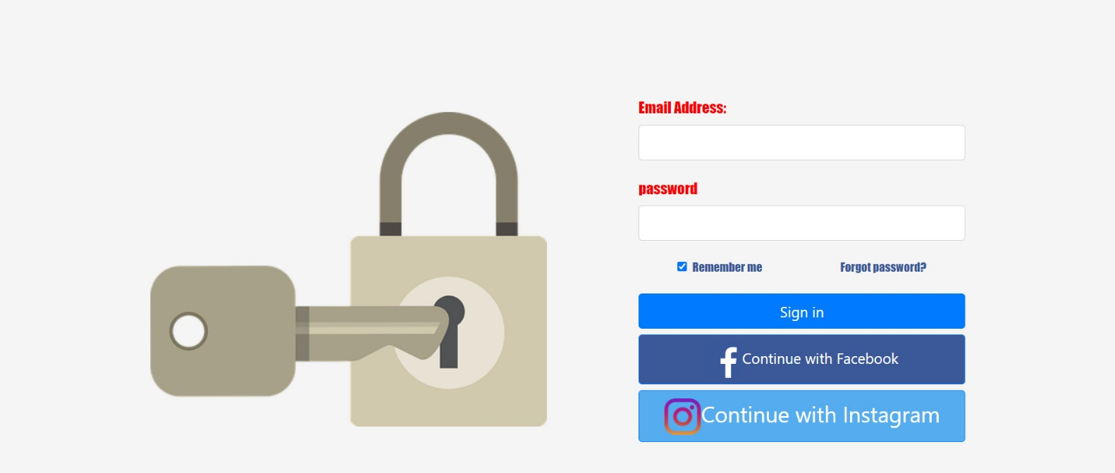

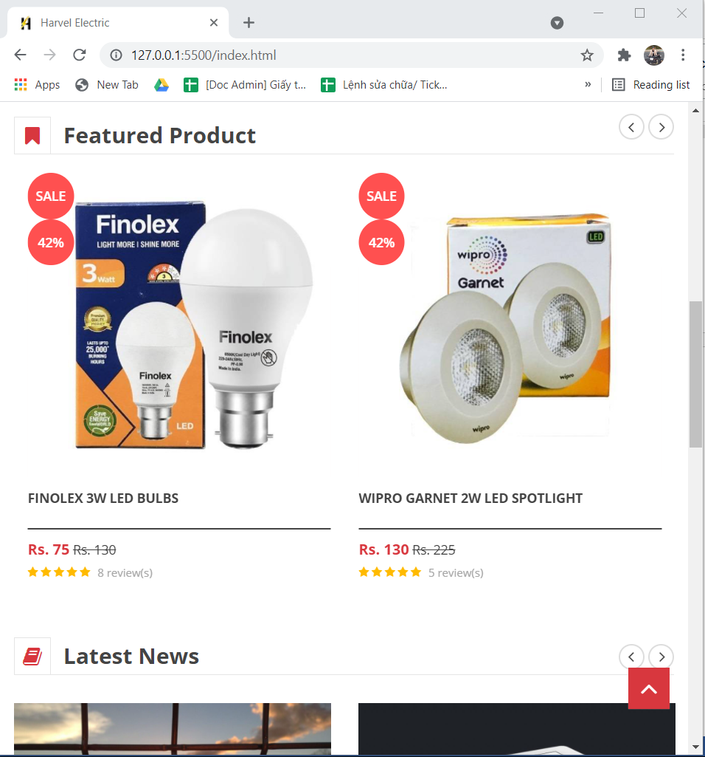

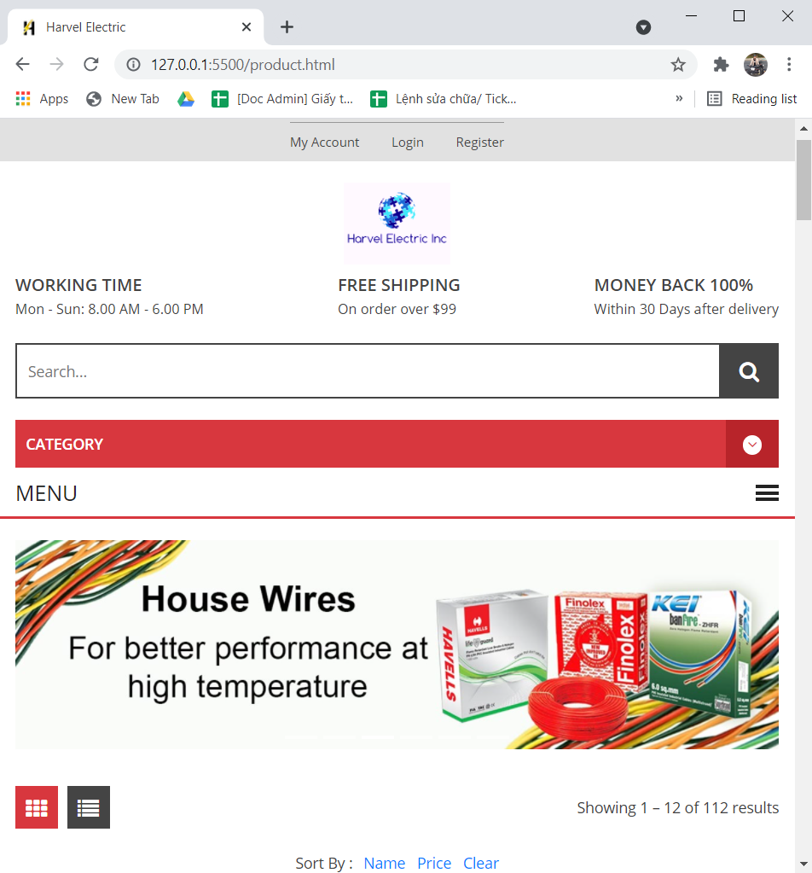

**JAVASCRIPT DESCRIPTION**

1. **Slider Javascript**
2. Description

This script used slick package (carousel) to display the products on the website.

1. Screen shot

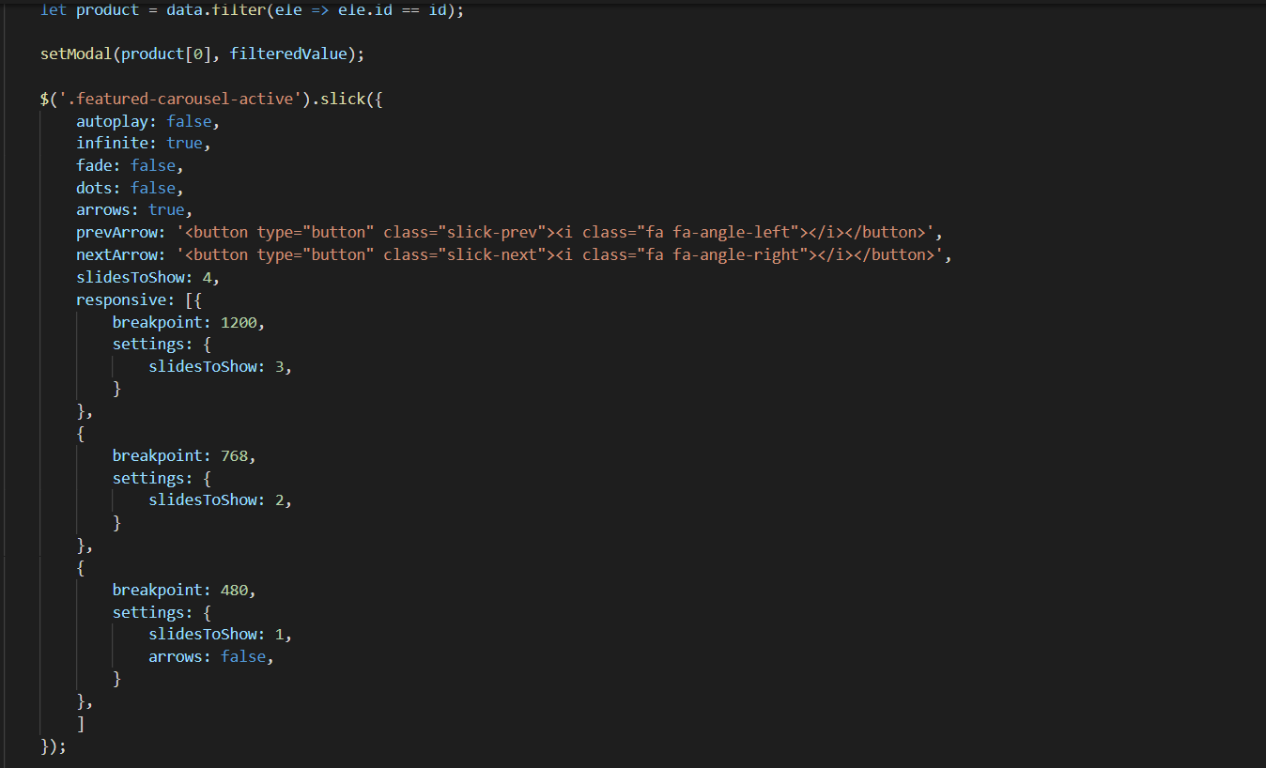

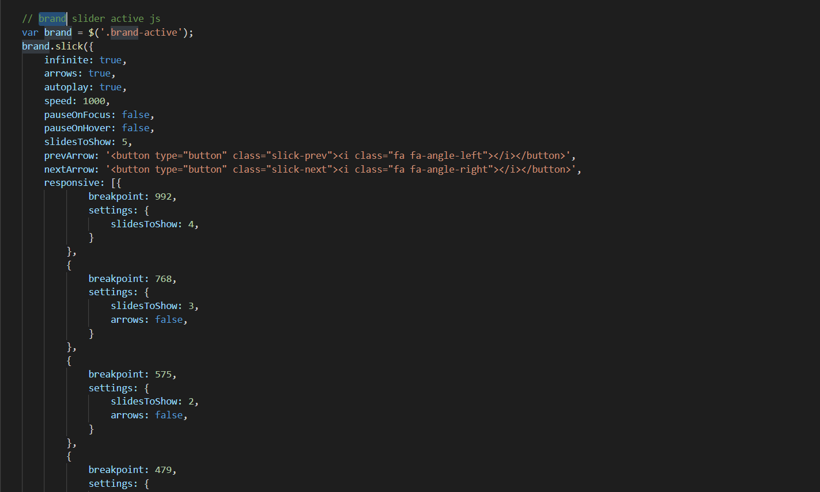

1. **Filter Javascript**
2. Description

This script is used to filter the product list by Type, Brand, Feature, Tag.

1. Screen shot

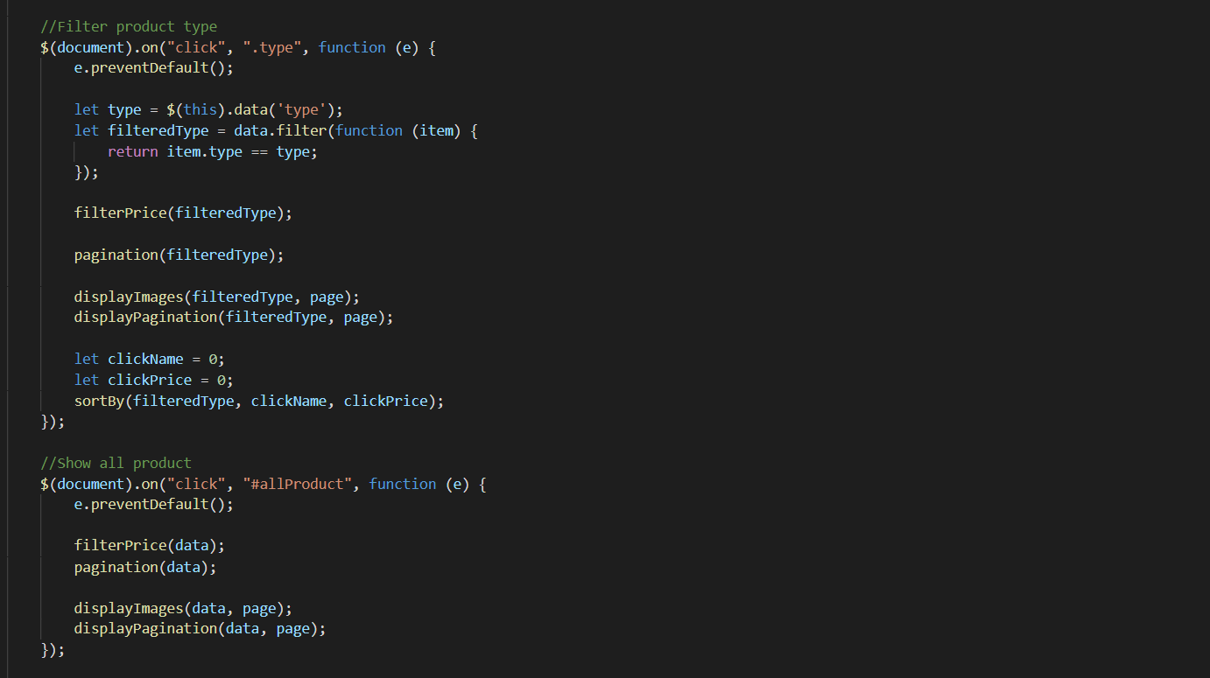

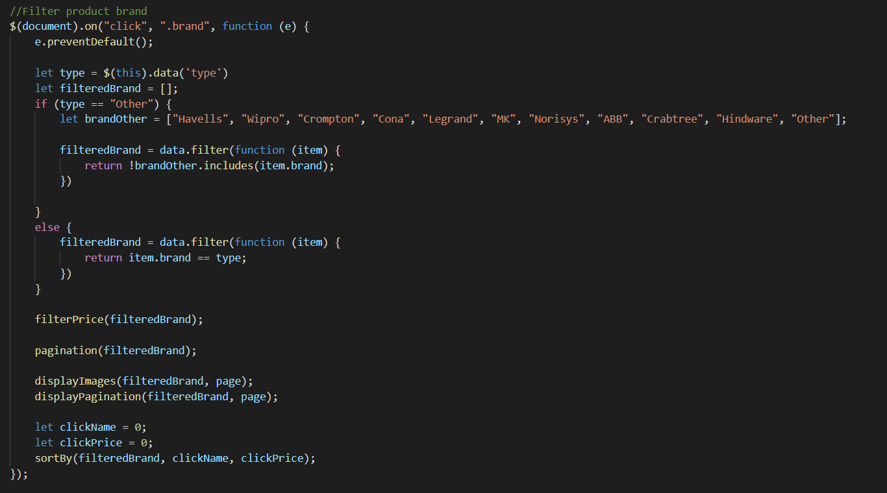

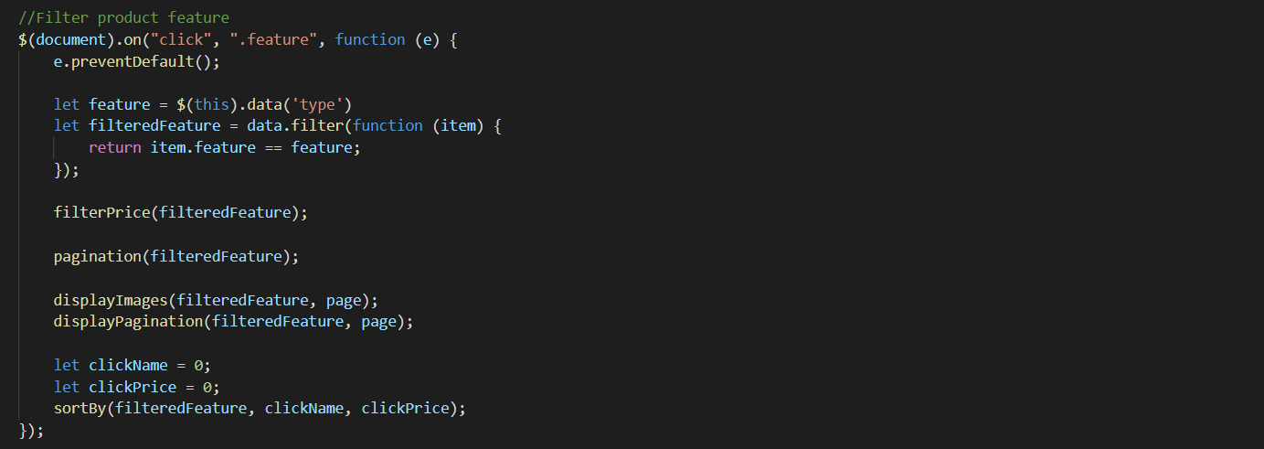

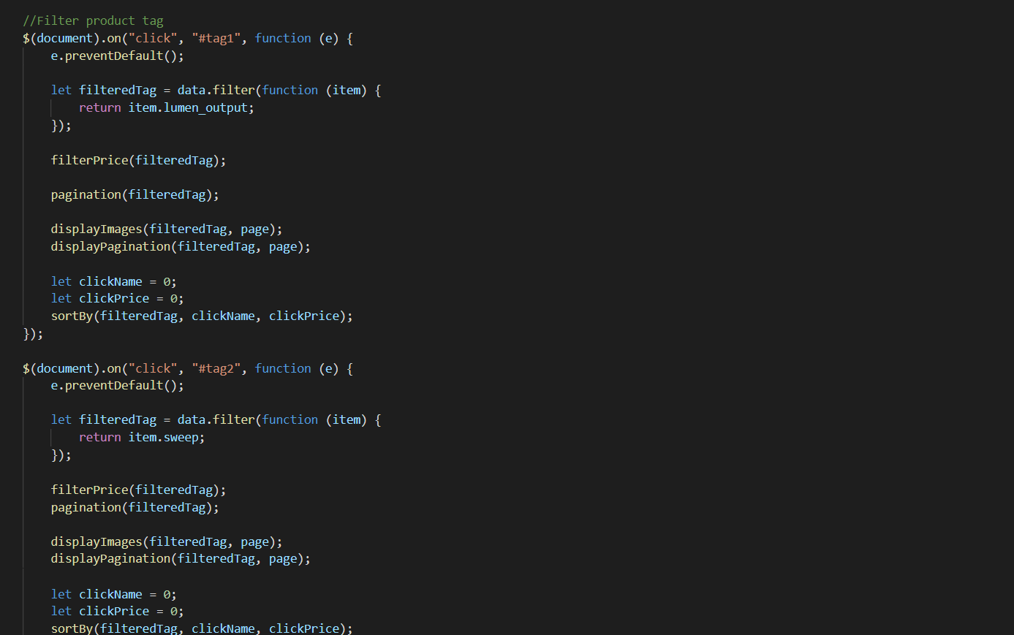

1. **Filter Price Javascript**
2. Description

- This script is used to filter the product list by Price.

- Users can adjust the price to filter products in the selected price bracket

1. Screen shot

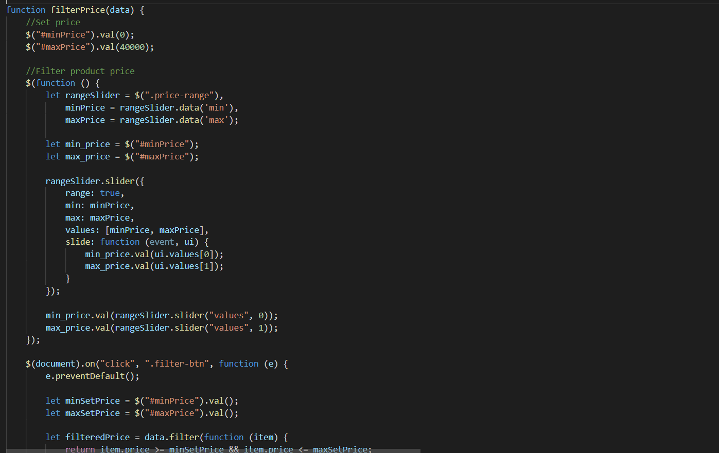

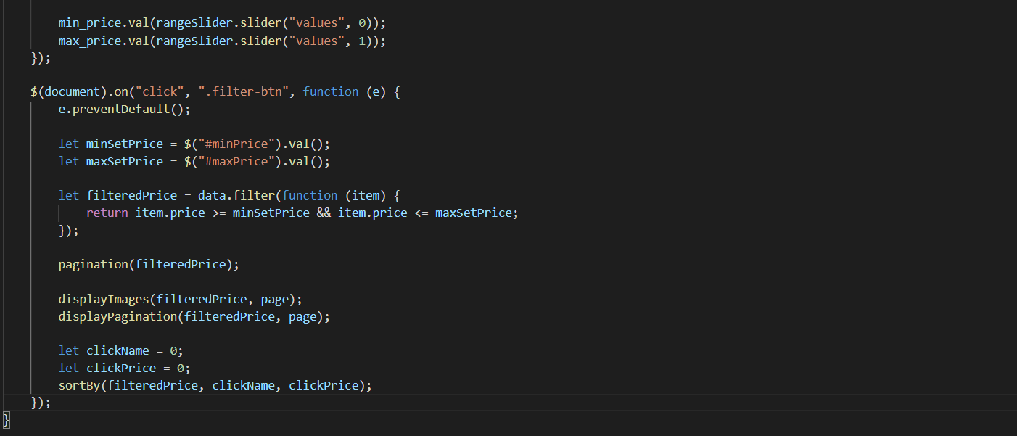

1. **Sort Javascript**
2. Description

This script is used to filter products by name or by price

1. Screen shot

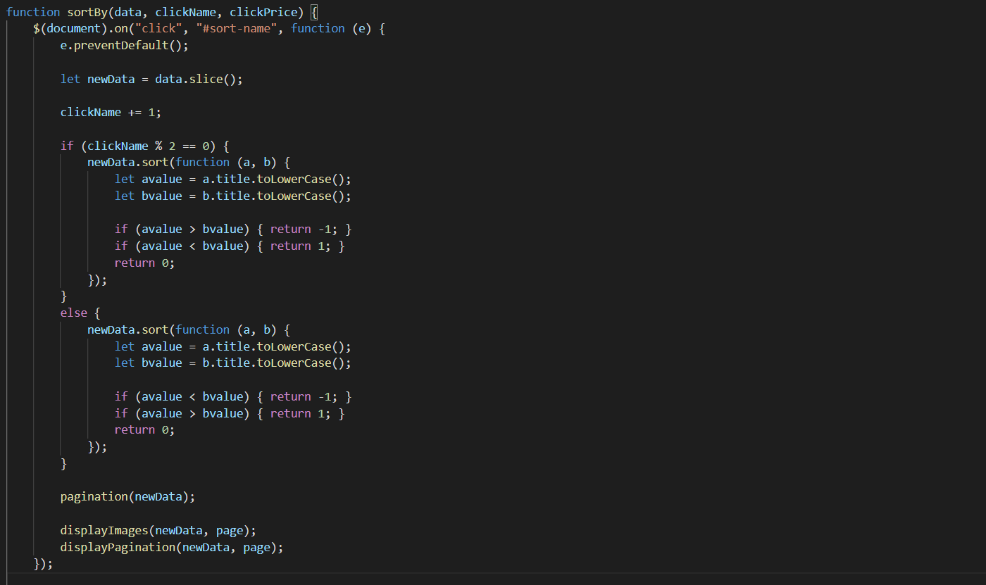

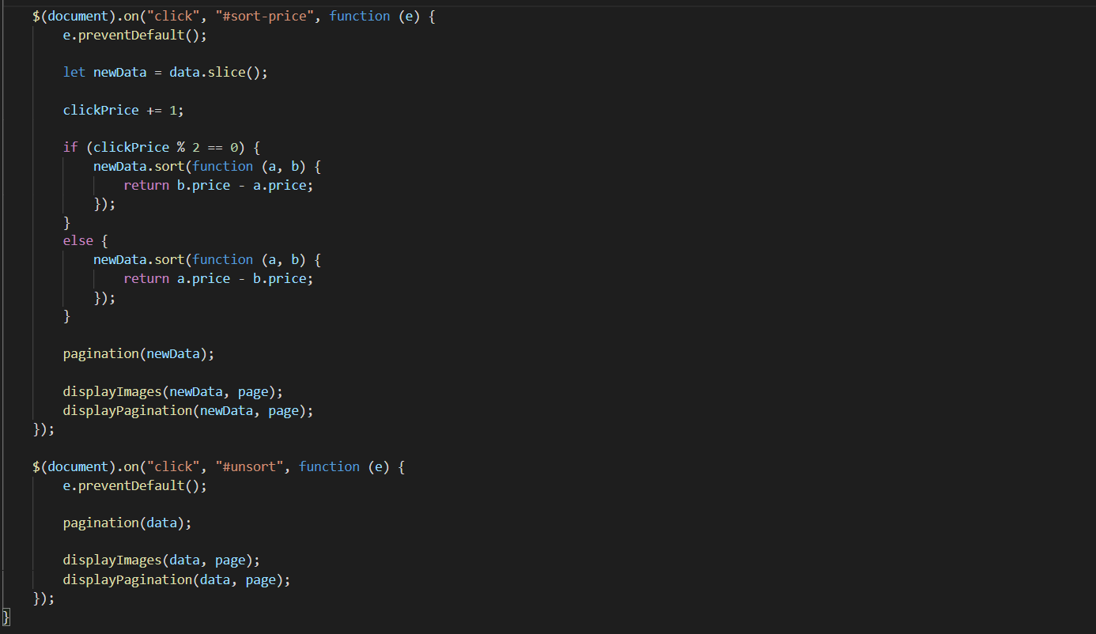

1. **Compare Javascript**
2. Description

This script is used to compare products of the same category

1. Sreen shot

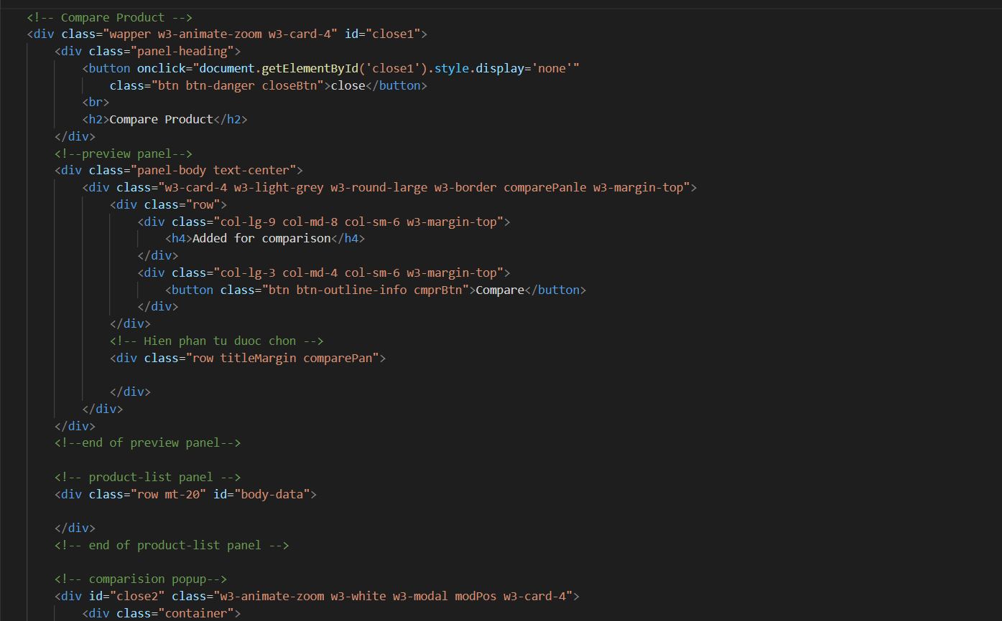

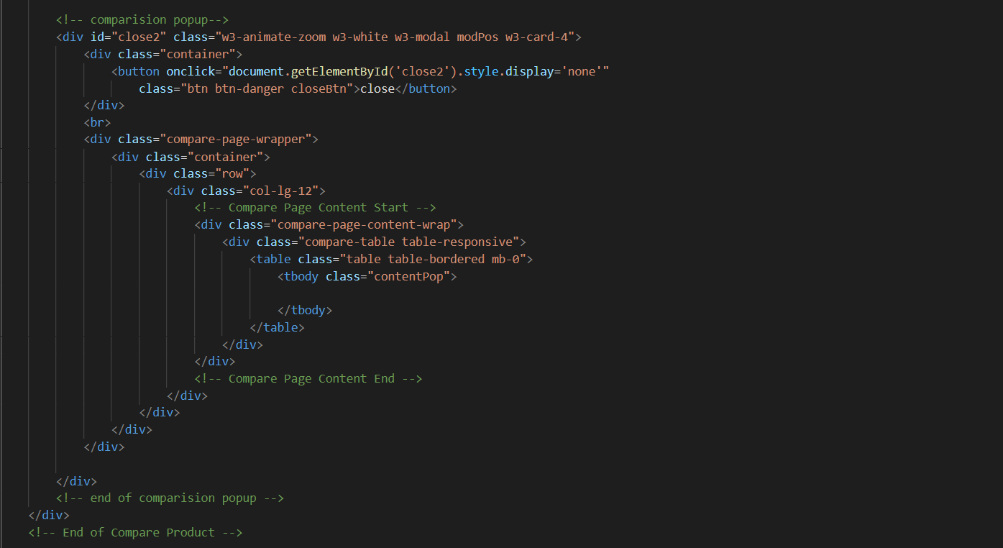

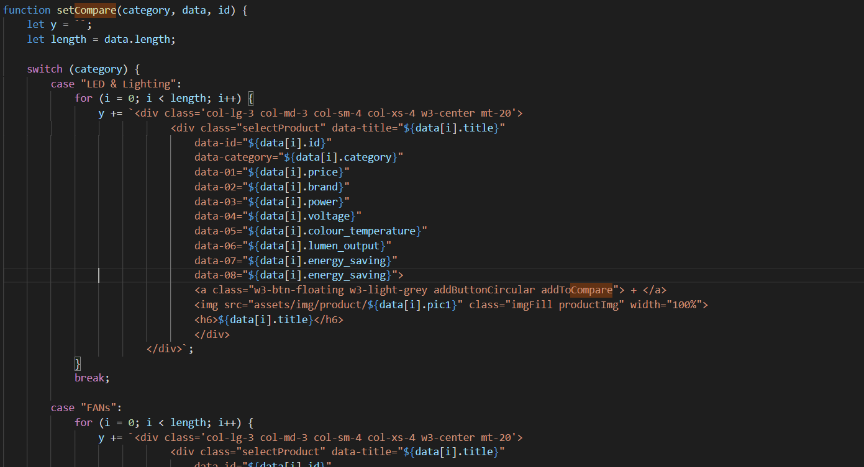

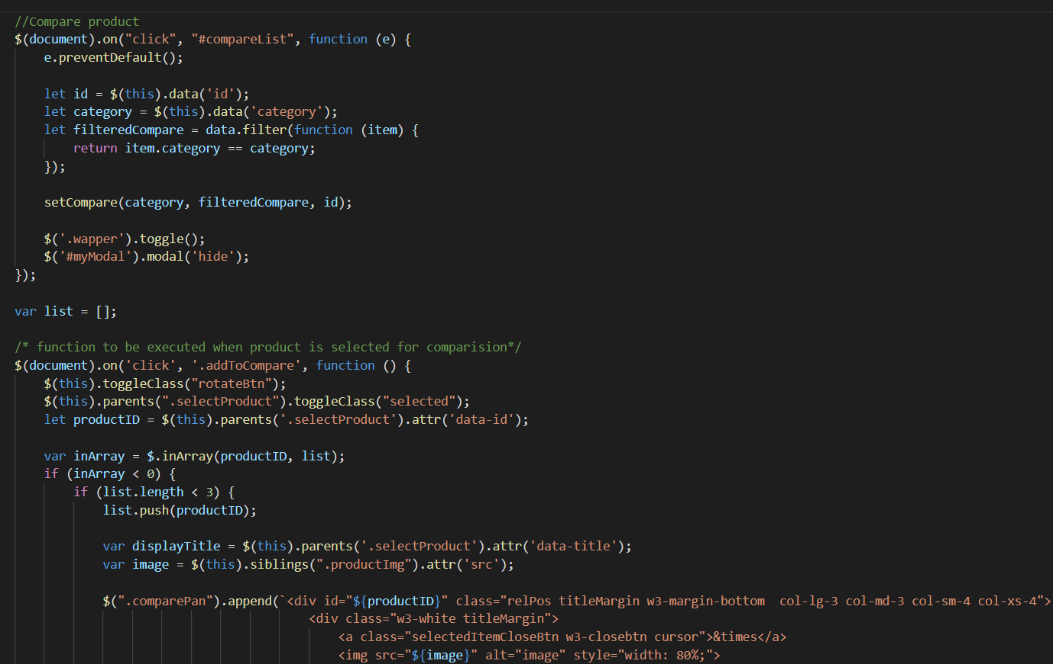

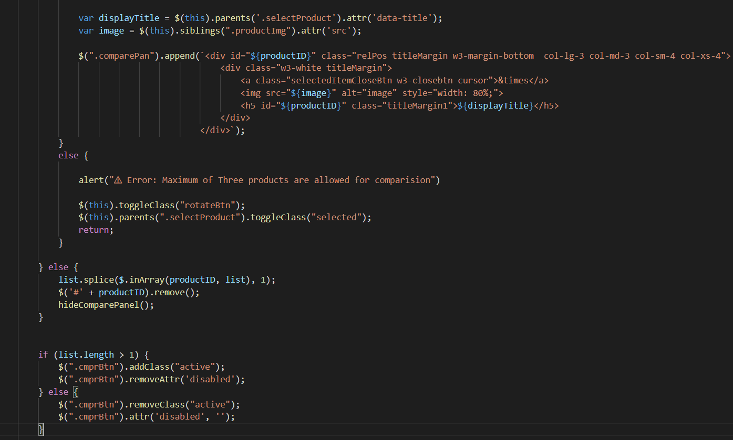

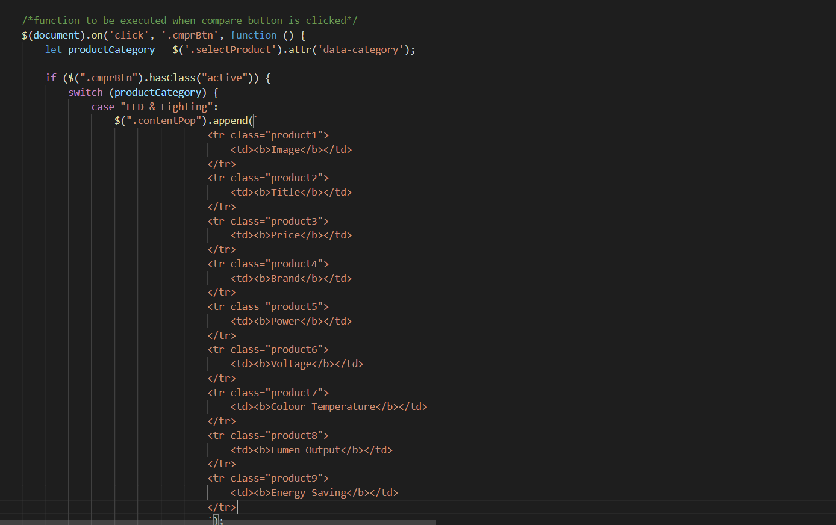

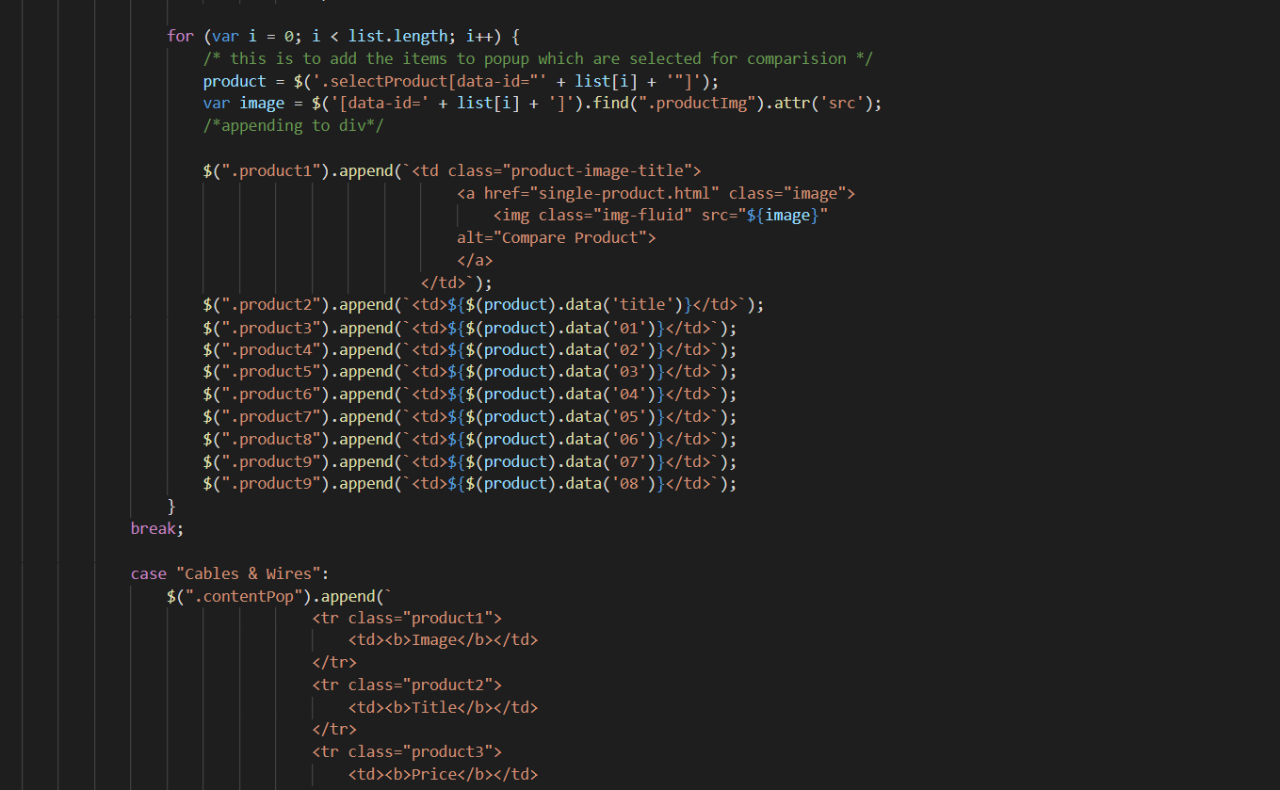

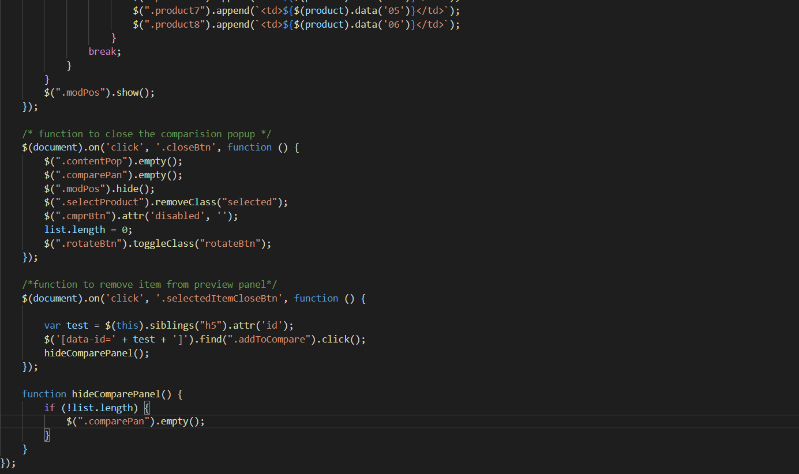

1. **Pagination Javascript**
2. Description

This script is used to paginate products into pages, each with twelve products

1. Sreen shot

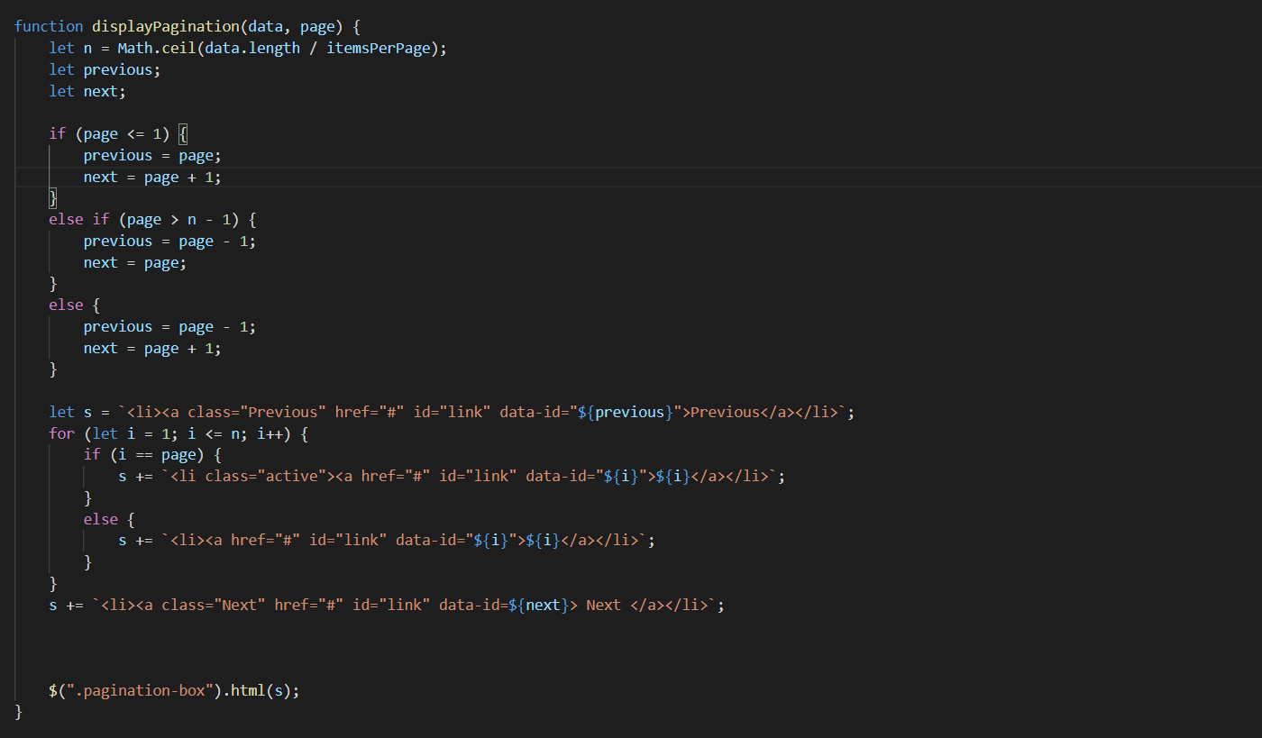

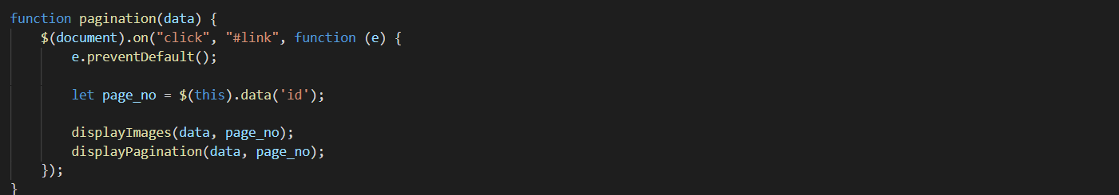

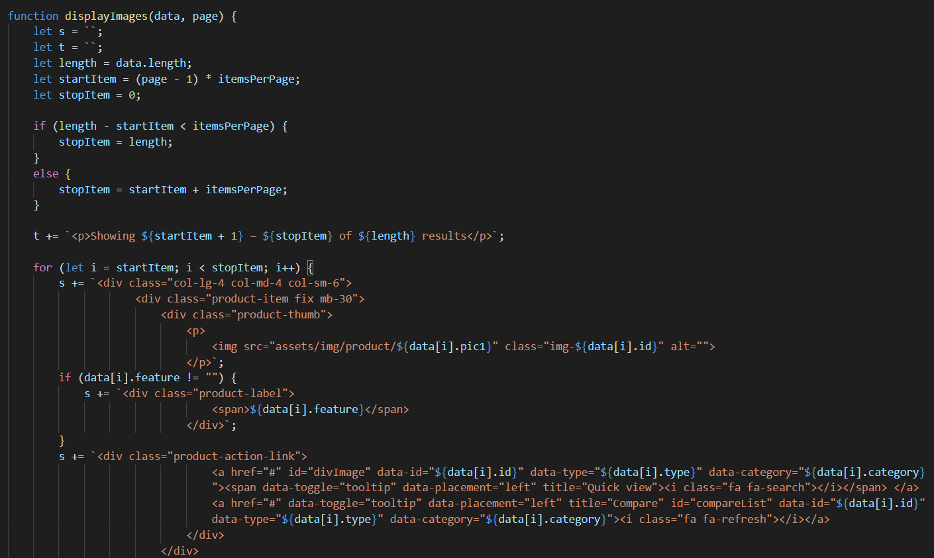

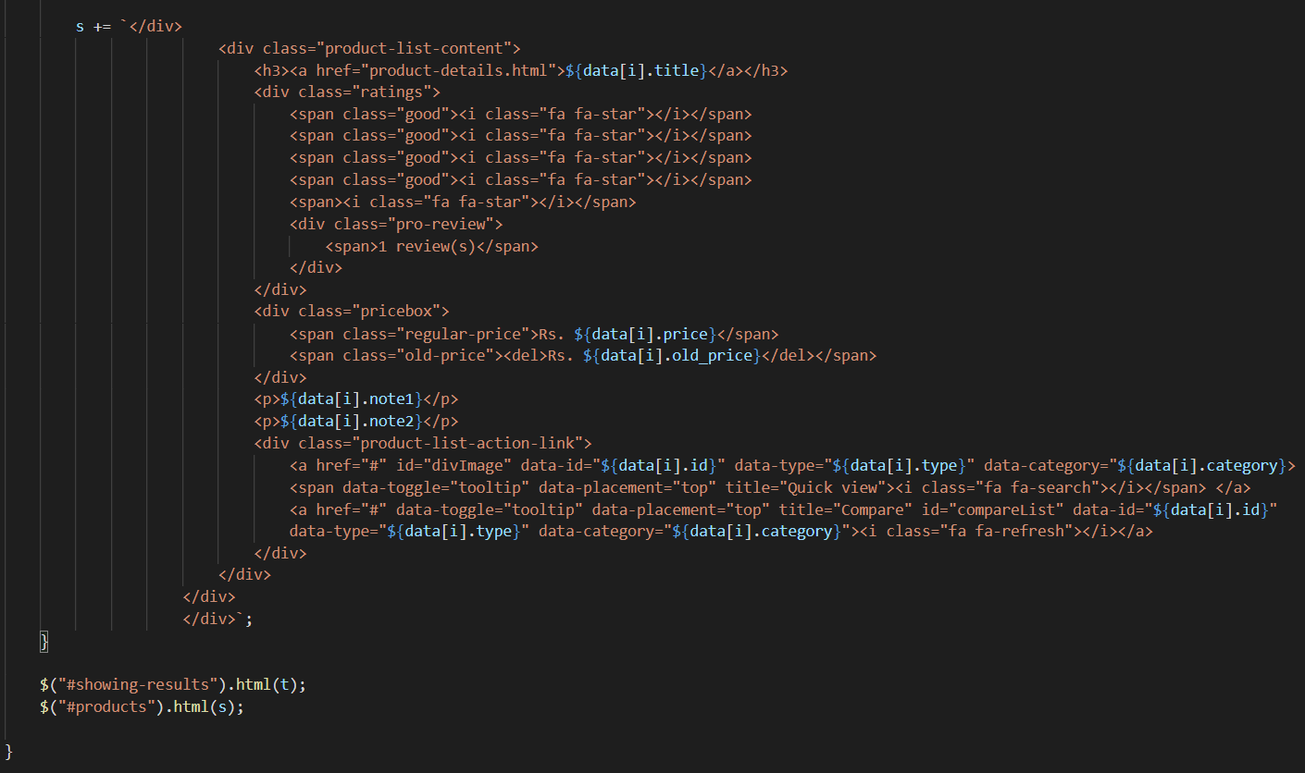

1. **Create Modal Javascript**
2. Description

This script is used to display product details in a modal format. Inside there are more products of the same type

1. Screen shot

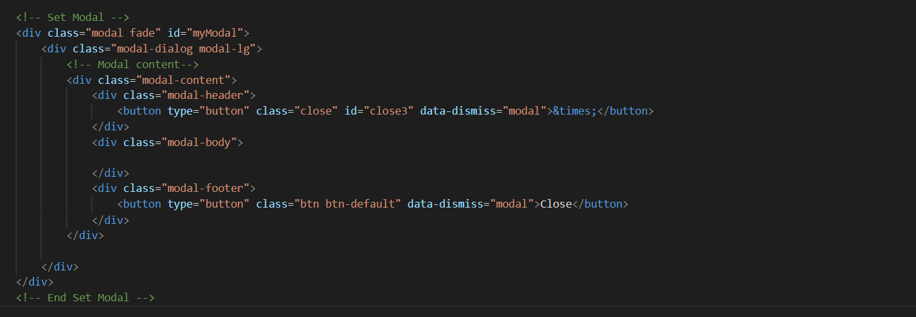

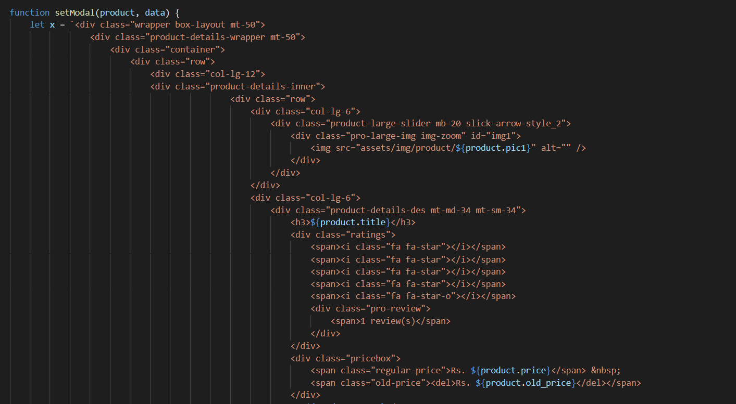

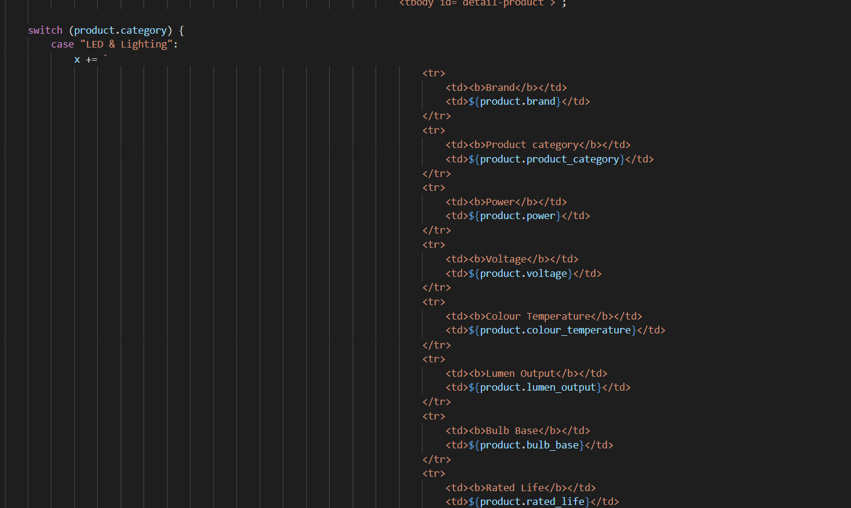

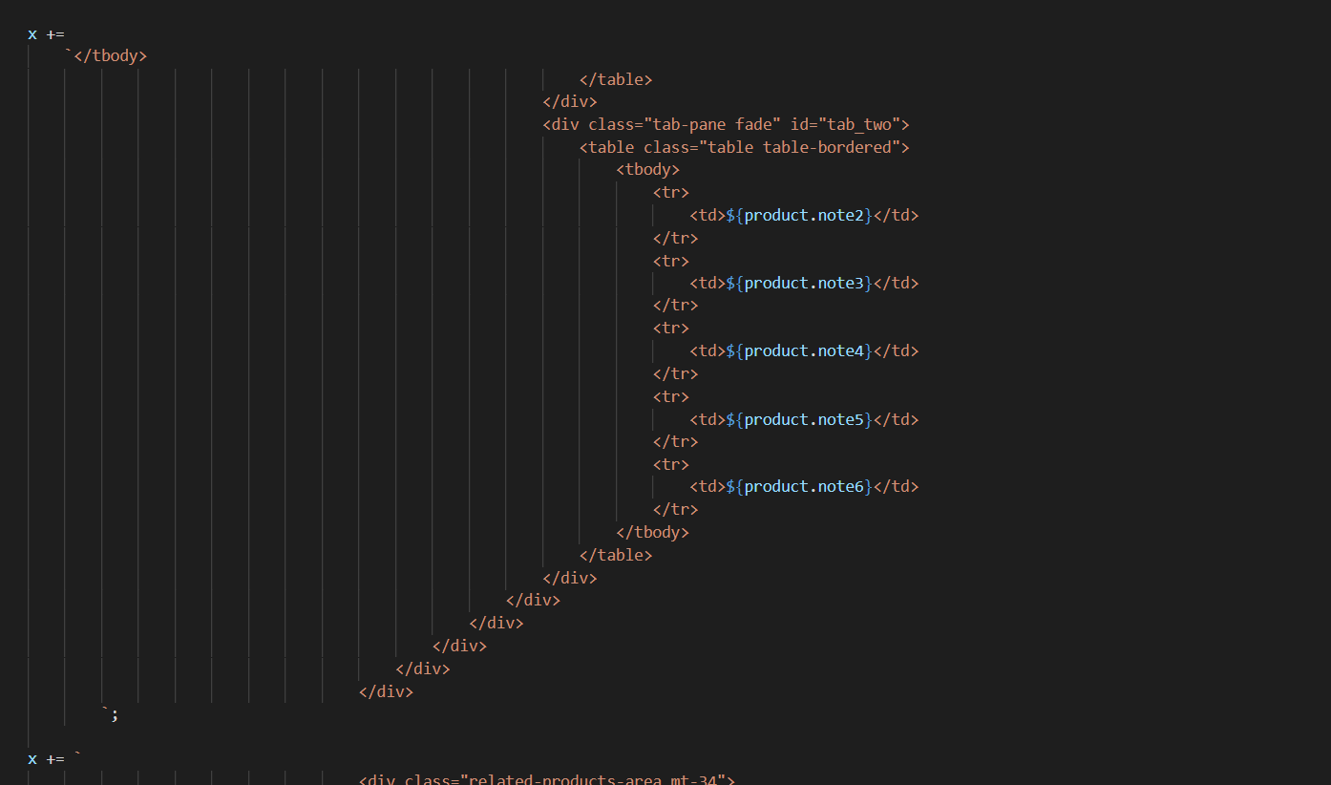

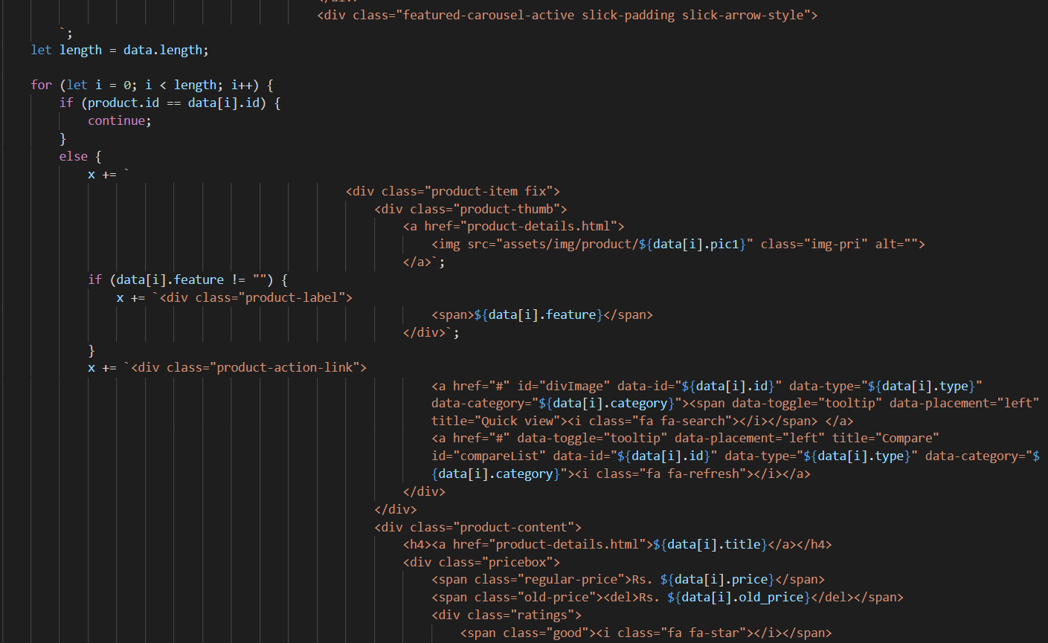

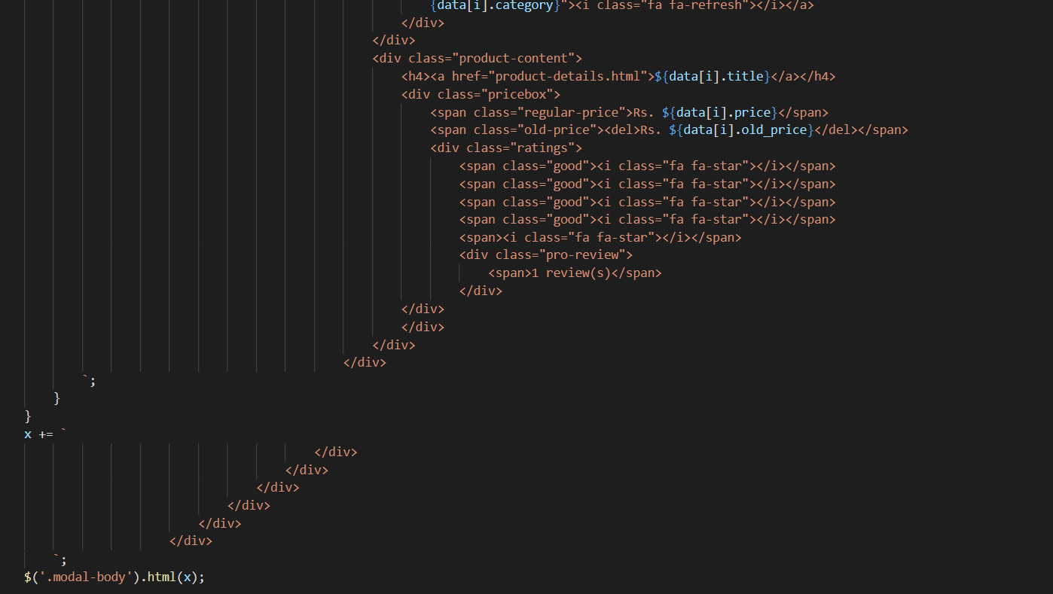

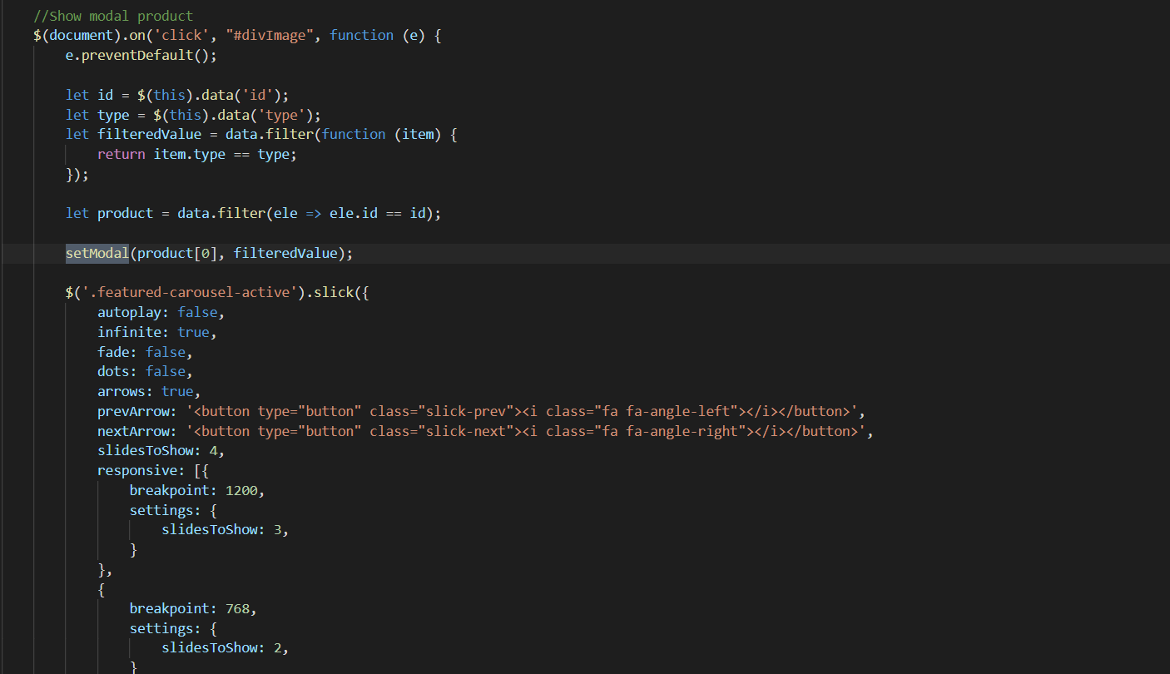

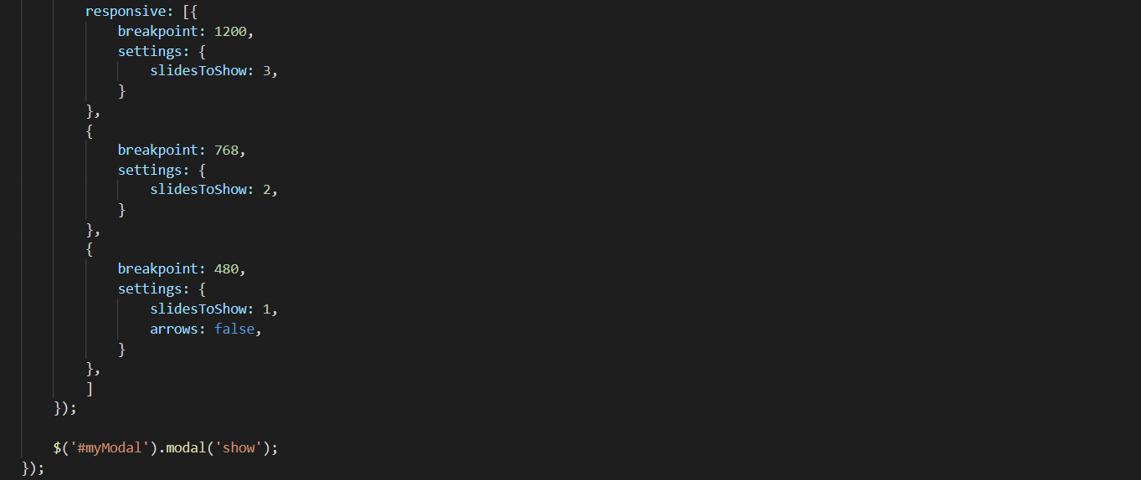

1. **Show number of product Javascript**
2. Description

This script is used to display the number of products by type, brand and feature

1. Screen shot
2. **Sign-in & Sign-up Javascript**
3. Description

This script used for member registration and login in the website.

1. Screen shot

# TASK SHEET REVIEW 3

|  |  |  |  |  |  |  |  |
| --- | --- | --- | --- | --- | --- | --- | --- |
| **Project Ref. No.:**  **eP/Advertisement Portal Management**  **System/01** | | **Project Title:** | **Activity Plan Prepared By:** | **Date of Preparation of Activity Plan:** | | | |
| **Sr.**  **No.** | **Task** | **Actual**  **Start**  **Date** | **Actual Days** | **Team**  **Mate Names** | **Status** |
| 1 | Home Page | RYANA CALENDARS | Phong | 18-July-21 | 1 | Thuy | Completed |
| 2 | Product | 20-July-21 | 3 | Mai | Unfinished |
| 3 | About Us | 20-July-21 | 2 | Phong | Unfinished |
| 4 | Contact Us | 18-July-21 | 2 | Mai | Completed |
| 5 | Java Script | 23-July-21 | 2 | Thuy | Unfinished |

|  |  |
| --- | --- |
| **Date:** | |
| Signature of Instructor:  **Ms. Le Mong Thuy** | Signature of Team Leader:  **Ly Hong Phong** |